1Q.WHILE

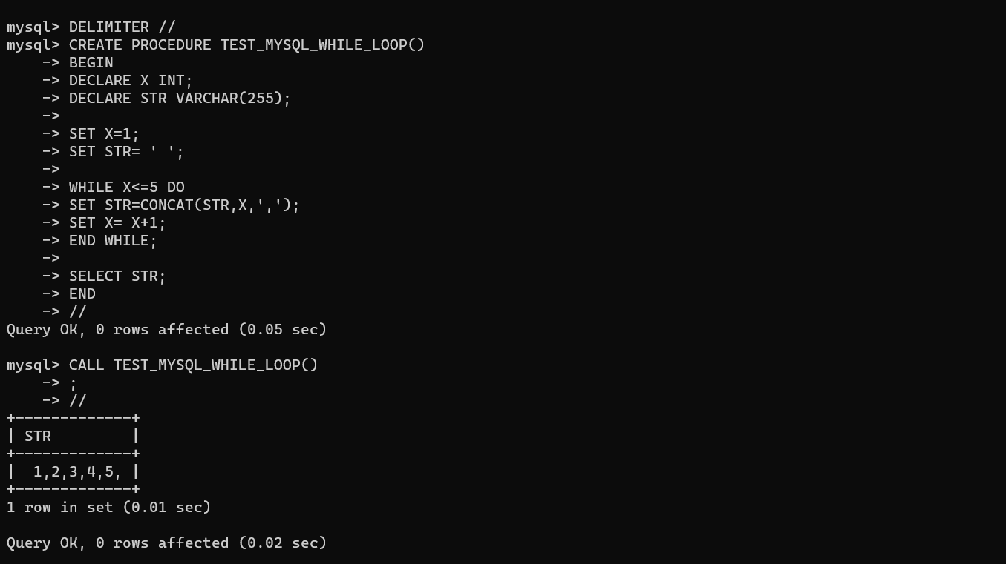

2Q.DOREPEAT

